Mount Tabor Circular

Getting there and parking

Meet at Mount Tabor Methodist Church, Mount Tabor Rd., Halifax. HX2 0UP. The church car park is currently available to be used free of charge.

Other Information

Walk length 3.2 miles.

Moderate Ability – Short steep uphill and downhill sections, otherwise an easy walk.

Toilets and drinks available at The Spring Head (licensed café and restaurant), near the start and end of the walk.

Walking Boots and Walking Poles advised due to sloping terrain.

Route Details and Reflections

Start at Mount Tabor Methodist Church.

With the main road in front of you, turn left up the hill, towards the bus stop. Just after you pass the bus stop on your left-hand side, turn left down a walled lane by Prospect Place.

Continue into a field keeping straight ahead and out into a lane.

Cross this lane and enter the field opposite through the gap in the wall.

The path is straight ahead down this field.

At the end of the field, pass down through a stone style and down several small steps to cross a lane. These could be quite slippy.

To the front, a fantastic view of Luddenden Valley.

Reflection Point 1 – View

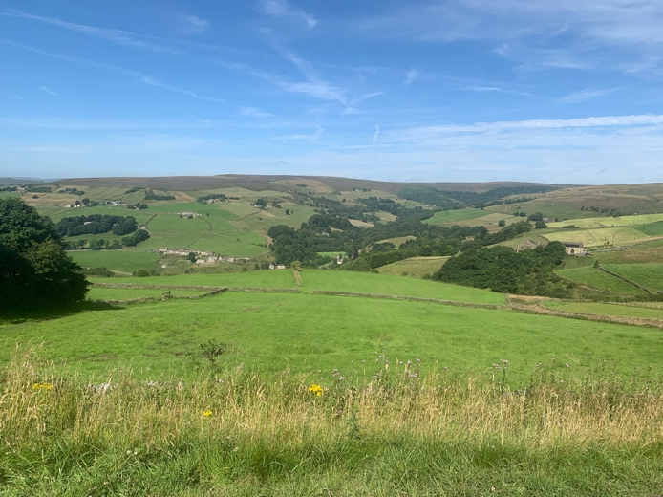

* Stop to take in the view of Luddenden Valley
* Close your eyes, take in a deep breath, and open your eyes as you breath out.
* What do you see?
* Sometimes we take something as simple, yet completely amazing, as our sight for granted. How would you feel if you could not see this view?
* There are many recorded miracles of Jesus giving sight to the blind. We don’t know how many miracles were performed as it often simply says ‘He healed them all’. He knew how important sight was to the people who came to him for help, and he restored it.
* Our eyes can take in over 10 million pieces of information per second and transfer them to our brain.
* Our sight may not be perfect, we may need to wear glasses, but let’s pause for a moment and **give thanks for the miracle which is our sight**.

JOURNEY ON crossing the lane to follow the track opposite~~.~~

The track avoids walking the main road and eventually comes out to rejoin the main road. Continue left (straight ahead) heading towards Wainstalls.

As you reach the Crossroads Inn, cross the road and continue straight ahead.

As you reach the junction of Wainstalls Road on your left-hand side, bear right across the road to enter a lane through a gap in the wall. It is opposite the road signs for the sailing club and school traffic.

As you reach the end of the lane, turn right to follow the wall around to the right along another lane.

As you reach the end of the lane cross the road to head straight up another walled lane, passing by the gate.

Stop as you climb to look back at the Crossroads.

Reflection 2 – Crossroads

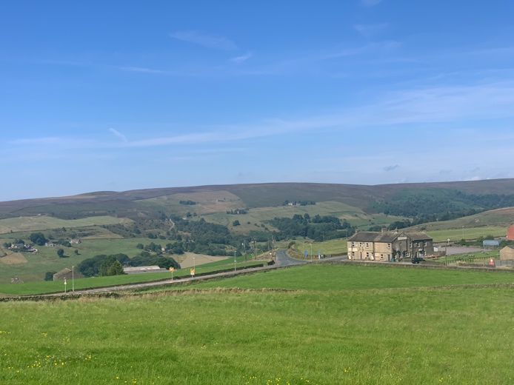

* Look back at the crossroads. We decided to walk straight on when we got there on the outward leg of the journey.
* Where would we have gone if we had turned left? Potentially lost!
* Where would we have got to if we had turned right?
* Answer – we would have cut short the journey and reached this same point but earlier.
* Think about your life’s journey, perhaps just the last couple of years unless you have brought a flask for a break ☺
* There may have been some ups and some downs, highs and lows. At the time, the lows (some unwanted detours) may have felt unconquerable. But you are here now!
* It rarely does us good to dwell on the past or worry about the future. Peace can only be found in the present.
* Let’s pause and **give thanks for where we are now.**

JOURNEY ON.

At the next crossroads, turn left down another wide lane, sign posted by a blue arrow (left-hand side).

As you reach a house on your right-hand side, follow the lane round to the right in front of the house (No. 3).

As you reach the main road (Moor End Road), turn left (passing 10 Green Royd on your left).

After a few hundred yards, cross the road. Stop at ’19 Moor End Road’ and look at Mixenden Reservoir

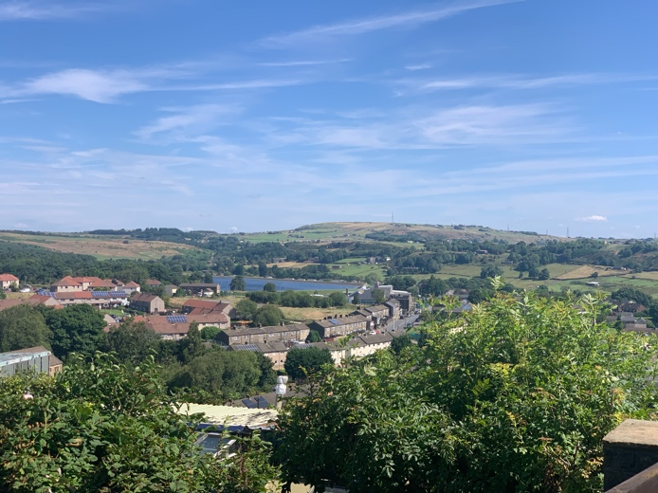Reflection 3 – Mixenden Reservoir

* In the distance is Mixenden Reservoir – a freshwater lake, where you can fish and there are over 180 recorded species of birds (according to Landscape Britain)
* Water – the most basic of essentials that we need to survive. Something else that we may take for granted.
* Is today sunny? You may be grateful that you brought a drink along with you on the journey. You may be grateful for the drink you had before you came or the drink you are looking forward to at the end of the walk.
* Simply pause and give thanks for the basic essentials that we often take for granted. **We are often richer than we may think.**

JOURNEY ON in front of 19 Moor End, turning right down the lane.

Take in the view of the viaduct, the Maltings and Fountainhead village.

The lane defends and levels off passing a cluster of older houses on the left hand side (inc Grindlestone Bank). Continue to pass Leighton Farm (left-hand side) and also pass Lower Scout Edge (right-hand side).

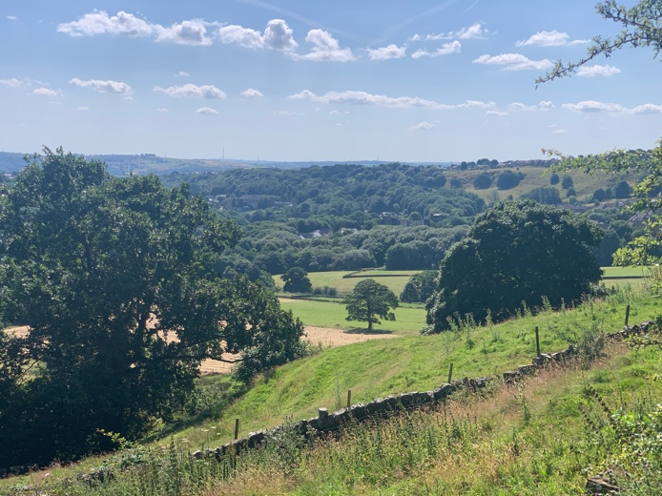

At the telegraph pole, the lane splits, take the right-hand fork up the hill (concrete paved)

The lane comes to a t-junction, which is Gibb Lane (cobbled). Turn right up the hill.

On reaching the road, cross over and enter a wooden gate etched ‘ Public footpath to Mount Tabor church and village’.

Refelction 4 – Etched gate

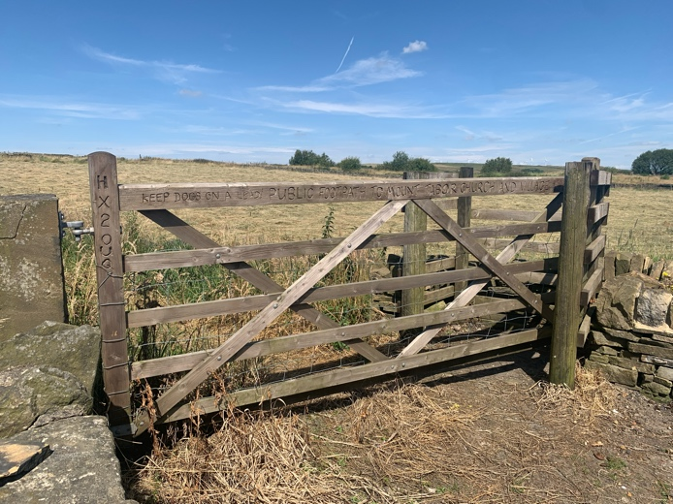

* What does it say on the gate?
* Someone has spent a long time etching into this gate instructions and guidance for your benefit.
* It tells you the destination – PUBLIC FOOTPATH TO MOUNT TABOR CHURCH AND VILLAGE.
* Mount Tabor church is our destination for today. Do we trust the sign that this will be the best way home? Do we trust the people who have done this walk before, that it’s the best way home?
* Perhaps both. The written word and people’s experiences.
* What do you put your trust in?
* Walking on a path reminds me of the proverb ‘Trust in the Lord with all your heart; do not depend on your own understanding. Seek his will in all you do and he will show you which path to take.’ *(Proverbs 3:5-6 New Living Translation)*
* Does that mean anything to you? **Do you want it to mean anything to you?**
* If so, read it again.

JOURNEY ON going through the gate along the path. Pass between the two field entrances to take a narrow, walled lane, which brings you out opposite the church. Cross over to return to the church.

The Spring Head licensed café is c. 75 meters down from the church, on the right-hand side.