Bluebell Trail – Binns Wood, Cromwell Wood & Freemans Wood

Getting there and parking

Meet at Cromwell Bottom Nature Reserve car park behind Cromwell House. HD6 2RG. No parking charges.

Other information

Walk length 3.3 miles.

Moderate Ability – 5 stiles

Toilets and café often open at Cromwell Bottom Nature Reserve at weekends.

Walking Boots essential and walking poles advised.

This woodland walk can be muddy in places, with some slightly steep descents and up-hill pulls. Upward pull of stone steps.

Route Details and reflections

Start at Cromwell Bottom Nature Reserve car park behind Cromwell House. Exit the car park and head back towards the main road. Cross the main road to enter the track directly opposite, heading uphill between two stone pillars. Then cross the stile.

As you reach the intersection of four metal gates, do not go through any of the gates. Instead, bear left up a muddy path (Binns Lane) which runs along the side of the wood on your left.

As the path climbs to reach a second stile, cross the stile and bear right continuing uphill along the path.

This path continues to Boggart House at the top of the hill. Take in the views

**REFLECTION POINT 1 – View at Boggart House**

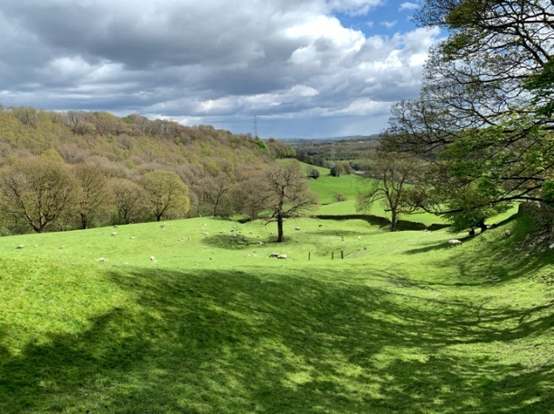

* **Take a look around what do you see?**
* **As you look at the landscape what do you notice?**
* **Think about how this landscape 100 years ago, what do you think you would still see?**
* **Woodland and trees are important to the whole ecosystem, think about how life would be different if this woodland had been felled and not replaced.**
* **Think about everything that is lifegiving that you see in front of you in this scene.**
* **Perhaps you might like to be thankful for this view and everything it brings to life within it.**

**JOURNEY ON**

The lane soon passes Ashday Hall on the left and then bends left. Just after 100 meters take the narrow path on the right between two metal gates.

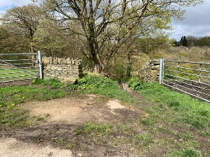

Follow the track as it bears round to the right passing between two stone pillars and a walled track. Pass Cote Hill farm, which is one of the oldest farms in Southowram.

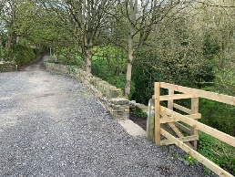Pass to the right of a metal gate through a wooden stockade, just beyond the end of a barn. About 40 yards further on your right, take the path down to the right, alongside the main track.

The muddy path soon levels off to a cobbled path.

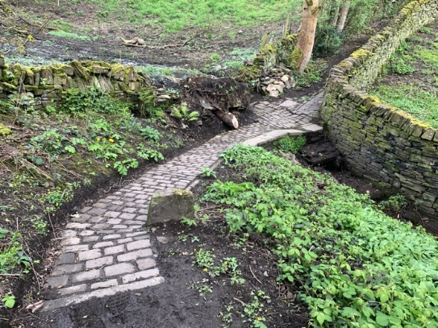**REFLECTION POINT 2 – Cobbled path**

* **Take a look around what do you notice?**
* **Think a bit more about this cobbled path**
* **Think about how long it might have been here.**
* **Think about who made it and why?**
* **Think about how many sets of feet have used this path over the years.**
* **Each person who has trod on these stones has been on a journey some knowing where they are going and perhaps some just wandering. Think if you are a purposeful journey person or a wanderer or perhaps different at different times.**
* **Each step we take each day generally has a purpose that we often don’t think too much about. When was the last time you just wandered, how did this make you feel?**
* **Perhaps we might be thankful for the things we are able to do without thinking about it like being able to walk.**

JOURNEY ON

As the path rises, it meets a junction of four lanes. Bear right, heading slightly downhill.

Continue ahead along the path ignoring a path off to the right marked Calderdale Way. Do not take that path. Continue ahead and see the bluebells ahead on your right.

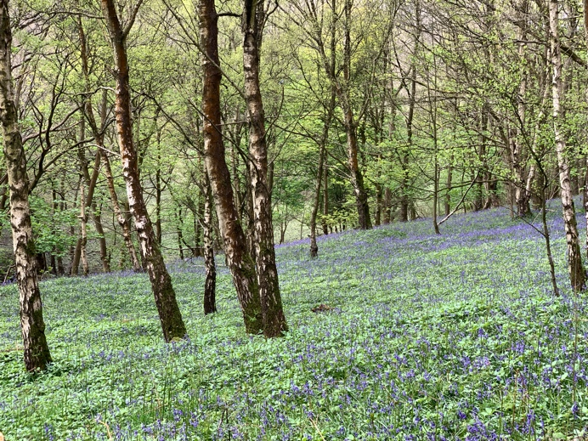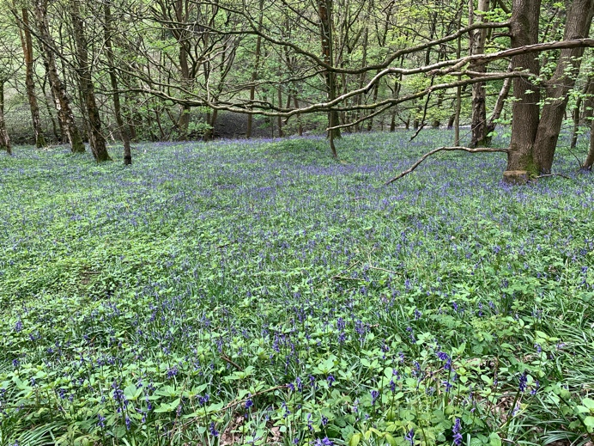**REFLECTION POINT 3 – Carpet of bluebells**

* **Take a look around, what do you notice?**
* **As you look around notice what is here now, be still and just take it all in.**
* **Think about how being here makes you feel.**
* **Think about in 6 months time the view you see and experience now will not be the same as the bluebells will not be visible. How does this make you feel?**
* **Jesus mentions about the lilies of the field and how God looks after the birds of the air and the flowers in the field. They don’t have to reap or sow and not worry about tomorrow. What do you think when you hear this?**
* **Within nature each year things come and go, as do these bluebells, which is part of the cycle of life. Think about how this helps you to live your life.**
* **Perhaps you might like to appreciate special moments in life like standing here today.**

JOURNEY ON

As the path continues downhill, you will see the end of a barn and a stone pillow on your right hand side. Immediately to your left you will notice some steps rising to a gate. Pass through the gate and take the steps leading uphill.

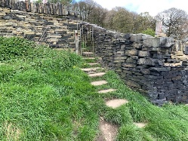

On reaching the top of the steps, cross the stile and you see a path arching round in front of you. Bear right to follow the walled track down to the right.

As the path works its way down, on your right the wall naturally ends at a gateway.

Do not go through the pillared gateway.

*[Note – the walk can be shortened at this point by passing through the metal gate on the right of the pillared gateway. This is Briar Lane which will take you back down, past the farm track, down to the main road and then turn right back to Cromwell bottom car park.]*

Otherwise continue on the main path, straight down the track with the wall on your right-hand side.

As you reach the bottom of the track, cross the stile and you arrive at the main road. Cross the main road and progress directly ahead down a lane called North Cut.

Just before the bridge, turn right down towards Brookfoot Lock, passing the angling lake on your right.

On reaching the bridge at Brockfoot Lock, cross the bridge and continue along the canal path.

**REFLECTION POINT 4 – Lock**

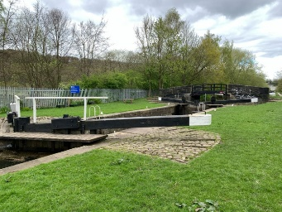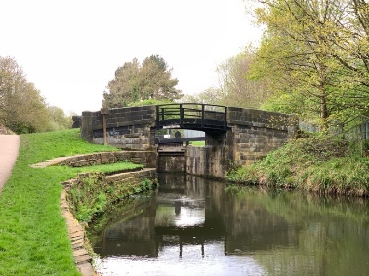

* **Take a look around what do you notice?**
* **Compare this view to the previous reflection point. Consider what the difference is between them.**
* **This canal and lock are man made and had an original purpose of helping transport goods and strengthen and support local businesses and the economy. Think about what other things now help to do that?**
* **Think about the amount of time, energy, knowledge and money it took to build not only this lock but every lock and canal in the country.**
* **Think about how the lock works using water and mechanics to alter the level of water in the lock.**
* **The canals are now mainly used for leisure purposes. Think about a time when you have been on a narrow boat or seen one go by. How did this make you feel?**
* **Being on the canal can help you to have a slower pace of life, think about the things that help you to slow down in life.**
* **Perhaps you might like to see these things as a gift and accept them as such.**
* **What things that you recognise in your life help you to slow down, take notice and reflect?**
* **Jesus said, “Peace I leave with you; my peace I give you. I do not give to you as the world gives. Do not let your hearts be troubled and do not be afraid.” John 14:27. Think about how that makes you feel.**
* **Remain silent for a short time.**

JOURNEY ON

Continue on the canal path.

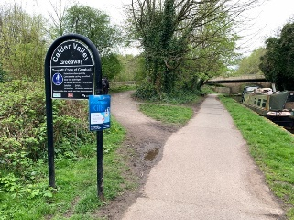As you reach the black-and-white Calder Valley Greenway sign on your left take a track off to your left heading away from the canal.

This is a short track which then bends round to the right to cross the bridge. Then turn right back to the car park.